IHE Change Proposal

Tracking information:
IHE Domain | PCC
Change Proposal ID: | CP-DOM-0052
Change Proposal Status: | Submitted
Date of last update: | 05/27/2009
Person assigned: | Tone Southerland

Change Proposal Summary information:
Header Information
Submitter’s Name(s) and e-mail address(es): | Mike Jolley mjolley@uhin.com
Submission Date: | 04/10/2009
Integration Profile(s) affected: | APR
Actor(s) affected: | If known at time of submission; enter "None" for purely editorial changes.
IHE Technical Framework or Supplement modified: | Version 1.0 2009/03/23
Volume(s) and Section(s) affected: | Volume 2
Rationale for Change:
2009/03/23 version line# 2385 paragraph.
The APR History and Physical 1.3.6.1.4.1.19376.1.5.3.1.1.16.1.1 needs to include “Need to include Language, Ethnicity, Husband/Domestic Partner, Father of Baby”; in the comment column.

Discussion 05/27/2009
Add this verbiage:

Spouse, Domestic Partner, Father of Baby, Ethnicity (as permitted), Primary Language and Religion (as permitted) should be included in the Header as needed.

Proposed changes should be introduced with “editors instructions” in a “box” such as:
Additional Descriptions to include: N/A

June documentation
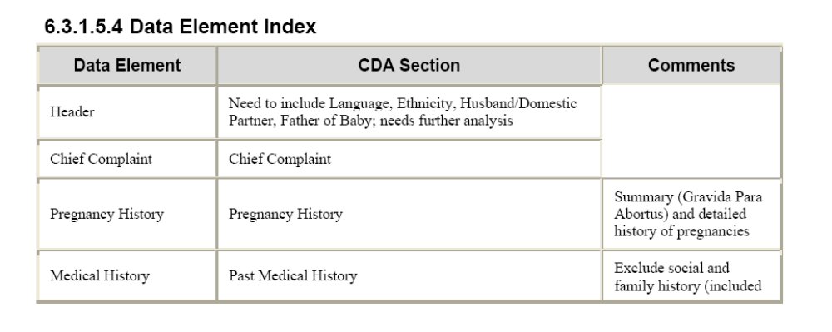

Current documentation
